It is the mission of the Nassau County School District to develop each student as an inspired life-long learner and problem-solver with the strength of character to serve as a productive member of society. In order to achieve this mission, it is crucial to develop the student as a whole including their mental and behavioral wellness.

This resource guide was created so those who are having a difficult time know where they can turn. This guide includes many providers from all walks of life and an assortment of specialties to help ensure you to find the correct fit.

This guide is not an endorsement of any particular agency, simply information on some of the resources that serve Nassau County youth and families. You may search psychologytoday.com for additional providers.

Reaching out for help does not have to be shameful or embarrassing. The sole purpose of this guide is to provide community members with the proper tools to help through difficult times.

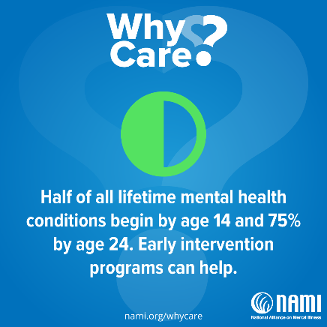

Please contact the mental health provider at your student’s school for more information.

Meredith Cohen, MSW

Mental Health Provider

Yulee Middle School

904-491-7944 ext. 5493

cohenme@nassau.k12.fl.us



**Nassau County, FL**

**Behavioral Health Community Resources**

For issues concerning substance use, mental health, and more.

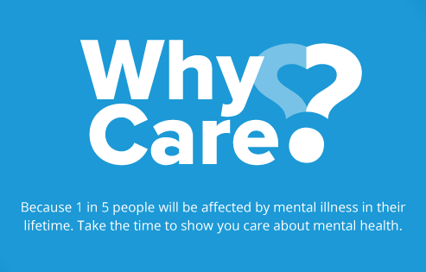

If your student has **health insurance**, first consider contacting your insurance provider to see what services and behavioral health providers may be covered with your plan.

Many employers offer an **Employee Assistance Program (EAP)** for employees and their family members. Consider exploring this as an option.

**Community mental health providers** receive government funding to provide free or reduced cost services and emergency services.

Community Mental Health Providers

* Florida Psychological Associates
  + (904) 277-0027
  + 1903 Island Walk Way, Fernandina Beach, FL 32034
* Starting Point Behavioral Health
  + (904) 225-8280
  + 463142 SR 200, Yulee, FL 32097

*If you believe you or another individual is suffering a mental health crisis or other medical emergency, seek medical attention immediately in an emergency room or call 911.*

*Private providers may accept insurance or are self-pay only. Please contact the provider for more information about services they provide and payment options.*

Private Providers

* About You Counseling & Coaching, LLC
  + Michelle Rampone, LCSW
  + (904) 729-4580
* Amelia Island Counseling, LLC
  + Megan Ienaro, LCSW
  + (904) 321-7351
* Amelia Island Psychology
  + Jean M Kerry PhD, LMFT
  + (904)-601-1026
* Amelia Psychiatry
  + Fernandina: (904) 321-8400
  + Yulee: (904) 432-0400
* Amelia Psychology Services, LLC
  + Dr. Ernest Paul Bicknell
  + (904) 628-2996
* Baptist Behavioral Health Services
  + (904) 376-3800
* Barnabas Center
  + (904) 261-7000
* Breakthroughs of North Florida
  + (904) 849-1190
* Clear View Concepts, Inc.
  + Robin C. Hampton, LMHC
  + (904) 335-0333
* Angeline R. Crawford, NCC, LMHC
  + (904) 289-5973
* McPherson Counseling Services, Inc.
  + 904-548-0160
* Maria Murphy, MA, LMHC, NCC
  + (904) 261-7022
* Candace Tierney, MA, LMFT, LMHC
  + (904) 491-8003

Additional agencies and resources

* Multiagency Network for Students with Emotional/Behavioral Disabilities (SEDNET)
  + (904) 336-4400
  + 2306 Kingsley Ave., Orange Park FL 32073
* National Alliance on Mental Illness (NAMI) – Nassau County
  + (904) 277-1886
  + nassau.nami.org
* Youth Crisis Center
  + (904) 725-6662
  + 3015 Parental Home Road, Jacksonville, FL 32216

Military and Veteran Families

Free counseling and supporting services

* Fleet and Family Naval Submarine Base Kings Bay
  + 912-573-4512
* Fleet and Family Mayport
  + 904-270-6600 ext: 1701
* Fleet and Family NAS Jacksonville
  + 904-542-5745

Hotlines

Free, 24/7, national, confidential resources

* National Suicide Prevention Lifeline
  + Call: 1-800-273-8255 (TALK)
* Crisis Text Line
  + Text: 741-741
* The Trevor Project: LGBTQ youth
  + Call: 1-866-488-7386
  + Text: 678-678
  + Chat: thetrevorproject.org